File Submission:

For this homework, each exercise needs to be submitted in the following format, i.e. all exercises and required files in its own folder. These folders need to zipped in one folder called LastName_File_Activities.zip and submitted. Follow the screenshot below.

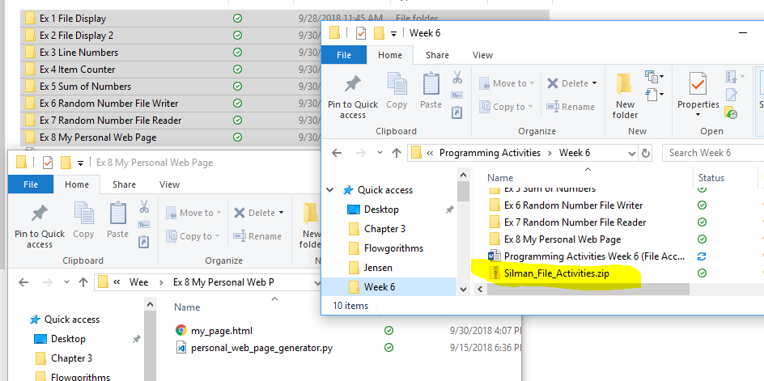

Exercise 1: Magic 8 Ball

Write a program that simulates a Magic 8 Ball, which is a fortune-telling toy that displays a random response to a yes or no question. Create a file contains 12 responses, such as “I don’t think so”, “Yes, of course!”, “I’m not sure”, and so forth. The program should read the responses from the file into a list. It should prompt the user to ask a question, then display one of the responses, randomly selected from the list. The program should repeat until the user is ready to quit. If the file is not found, throw an error.



Exercise 2: Charge Account Look Up

The file **charge_accounts.txt** has a list of a company’s valid charge account numbers. Each account number is a seven-digit number, such as 5658845.

Write a program that reads the contents of the file into a list. The program should then ask the user to enter a charge account number. The program should determine whether the number is valid by searching for it in the list. If the number is in the list, the program should display a message indicating the number is valid. If the number is not in the list, the program should display a message indicating the number is invalid. If the file is not found, throw an error.



Exercise 3: World Series Winners (4 pts)

Review the text file named **WorldSeriesWinners.txt**. This file contains a chronological list of the World Series’ winning teams from 1903 through 2009. The first line in the file is the name of the team that won in 1903, and the last line is the name of the team that won in 2009. (Note the World Series was not played in 1904 or 1994. There are entries in the file indicating this.)

Write a program that reads this file and creates a dictionary in which the keys are the names of the teams, and each key’s associated value is the number of times the team has won the World Series. The program should also create a dictionary in which the keys are the years, and each key’s associated value is the name of the team that won that year.

The program should prompt the user for a year in the range of 1903 through 2009. It should then display the name of the team that won the World Series that year, and the number of times that team has won the World Series. If the file is not found, throw an error.



